International Association of Geomagnetism and Aeronomy
IAGA-Scientific Symposia, Toulouse, France; July 18-29, 2005

THEORY FOR ANTIPROTON CONTENT
OF PLANETARY MAGNETOSPHERES

W. N. Spjeldvik⁽¹⁾, A. A. Gusev^{(2,3)}, I. M. Martin⁽⁴⁾,
G. I. Pugacheva⁽²⁾, S. Bourdarie⁽⁵⁾, and N. J. Schuch⁽²⁾

(1) Weber State University, Ogden, Utah 84408-2598, USA;
(2) Unidade Regional Sul de Pesquisas Espaciais, INPE, 1220,
1970 Santa Maria, Brazil;
(3) IKI, Space Research Institute of the Russian Academy of
Science, Moscow, Russia;
(4) Universidade Taubate, UNITAU, Taubate, Brazil;
(5) ONERA-CERT/DESP, BP 4025, F-31055 Toulouse, France.

ABSTRACT:

Antiprotons are generated in the interstellar medium and also locally in the Earth's and other planets' inner magnetospheres by processes mostly driven by galactic cosmic rays. When the collision rate is low, antiparticles can co-exist with matter-particles in a tenuous magnetically confined plasma. We have considered the various source mechanisms applicable to a planetary magnetosphere, the confinement duration versus transport processes, and the antimatter loss mechanisms. Using planet Earth as an example, additional interstellar antiprotons penetrating into the magnetosphere are themselves of secondary origin, i. e. they are formed in nuclear reactions of cosmic rays passing through 5 to 7 g/cm² of interstellar matter. In contract to this large scale process, magnetospherically generated antiprotons are generated at a pass-length of several tens g/cm² matter in the ambient upper planetary atmosphere and exosphere. By the build-up over time, one can expect that the magnetically confined fluxes will significantly exceed the fluxes of transient interstellar antiprotons that pass through the Earth's magnetosphere.
We present results of a numerical solution of the antiproton diffusion equation for the Earth's equatorial magnetosphere in the energy range from 10 MeV to multiple GeV. Antiprotons at tens of MeV are formed at substantially higher energies, and have subsequently been degraded in energy by the distant (Coulomb interaction) encounters that occur without annihilation losses. By magnetospheric transport processes, the antiprotons become distributed over a wide range of radial distance, although the peak antiproton fluxes for the Earth's magnetosphere is typically found around L=1.2 (h~1275 km). The present work is limited to the equatorial magnetosphere, although future extensions to the full three dimensional magnetosphere can be made.

INTRODUCTION:

At present time, the results of all known measurements of the interstellar antiproton spectrum support the idea of their secondary origin, namely that they are produced by the primary cosmic rays (CR) in collisional nuclear reactions with interstellar matter. This is thought to take place in the process of the cosmic ray particle's chaotic motion within galactic magnetic fields during the confinement time in Milky Way Galaxy.

Naturally, nuclear reactions similar to those of CR with the interstellar medium also take place in the Earth’s exosphere and atmosphere, even at the uppermost residual atmosphere at high altitudes above 1000 km. A great variety of secondary particles including antiprotons are produced in these reactions. A fraction of the secondary particles, which are born within the confinement region of the Earth’s magnetosphere are consequently durably trapped by geomagnetic field. This creates an antiproton radiation belt around the Earth, similar to the belts of positrons and the light element isotope ion radiation belts that are also created through the nuclear collisions of CR at altitudes of about 1000 km above the Earth’s surface (i. e., Gusev et al., 1996; Selesnick and Mewaldt, 1996; Spjeldvik et al., 1998; Gusev et al., 2001).

The galactic antiprotons impinging upon the Earth’s magnetosphere boundary with the energies lower than magnetospheric cut off rigidity also penetrate into the magnetosphere. We here present estimates of the trapped antiproton fluxes in the energy range from 10 MeV to several GeV produced by CR in the Earth’s rarified atmosphere and by the galactic antiprotons that diffuse into the Earth's magnetosphere. In the simulations we have included a mathematic simulation of the radial diffusion process. This entails both "inner" and "outer" antiproton sources, as well as losses of antiparticles due to ionization process, annihilation and nuclear interactions with the ambient matter. The estimates presented herein show a significant excess of magnetospheric antiproton fluxes over those formed in the interstellar medium at energies < 1 to 2 GeV.

FORMING THE ANTIPROTON BELT

Disregarding diffusion processes, the trapped antiproton flux is defined by solution of equation (1):

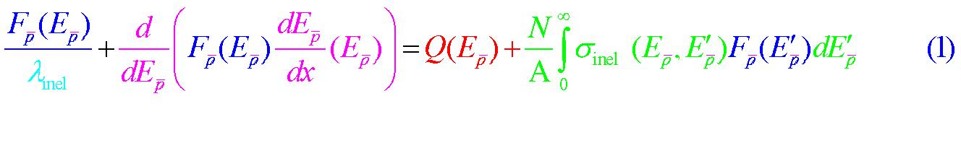
Q_{p}(E_{p}) is the antiproton production spectrum (here used as our source function, depicted in Figure 1 ) within the magnetosphere as computed on the basis of the nuclear cascade SHIELD code. λ_{inel} and σ_{inel} are the path length and cross section for inelastic nuclear interactions, using the "leaky box" model. The integral in the right hand accounts tertiary antiprotons (i. e., Gusev et al., 2003). Jones et al. (2001) provides a general description pf the parameters in the "leaky box" model.

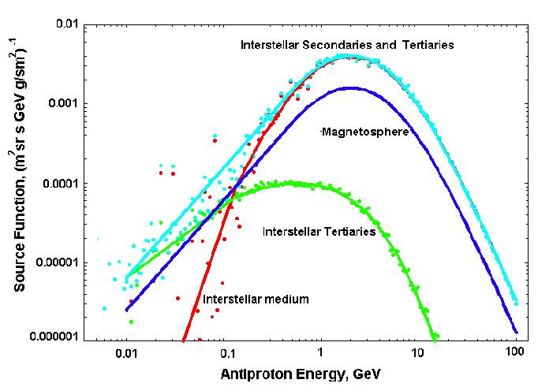
Figure 1: Results from using the SHIELD code in computing
the generation source functions for antiprotons
in the Earth's magnetosphere at L~1.2 and by interstellar
collision processes.
In Figure 1, the blue line represents the magnetospheric antiproton production rate at the peak nuclear interaction location (h~1275 km) while the red line estimates the interstellar production of (secondary) antiprotons. The tertiary process is shown as the green line and the light-blue line represents the total interstellar production. All curves are shown versus energy of the newly born antiprotons.

Figure 2 shows the characteristic cross sections for antiproton inelastic nuclear reactions and annihilation in atomic H, He and O targets (e. g., Letaw et al, 1989; Ng and Tang, 1983; SHIELD code results by Dementiev & Sobolevsky, 1994). The specific processes are noted on each of the curves. These are the atomic constituents that are most abundant in the uppermost Earth atmosphere.

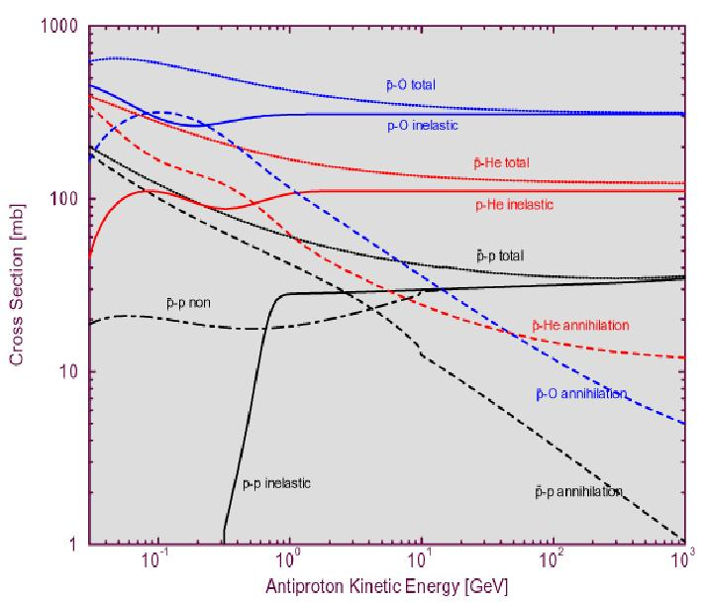
Figure 2: Nuclear interaction cross sections (in millibarn)
for the pertinent processes pertaining to antiproton
formation in matter.
Because of the tenuous nature of interstellar space, and because the Earth's magnetosphere also has a low density of neutral matter particles, the free path lengths of energetic particles and antiparticles tend to be long, with a corresponding long time between nuclear collisions. Figure 3 shows the antiproton interaction lengths Λ_{inel} = A/σ_{inel}N_{A} in H, He, O targets in the atmosphere for L=1.2 (h~1275 km), where the H, He and O atom number densities are in proportion 1.43: 29.8: 68.76, and in the interstellar medium. Numerical integration of Eq.(1) was carried out with the Mathematica program.

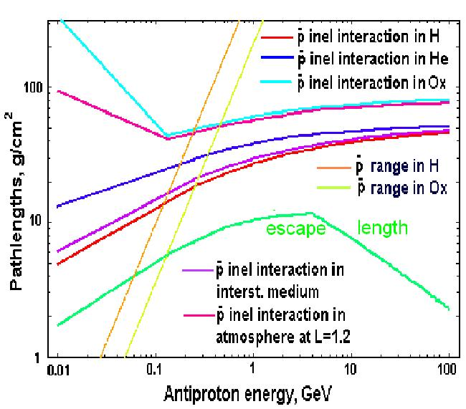
Figure 3: Estimated inelastic interaction pathlengths in
the interstellar medium, and in exospheric gas
components: atomic H, He, O

Based on the source function of antiprotons, as computed with the SHIELD code, Figure 4 shows the computed geomagnetically confined antiproton flux at L=1.2 resulted from solving Equation (1). We also compare it with the characteristic empirical galactic antiproton flux during minimum and maximum solar activity. The figure demonstrates the relative importance of the various processes for the magnetospheric antiproton flux formation.

Figure 4: The Magnetospheric Antiproton Spectrum at the
dominant production location (L~1.2) stemming
from the "inner" (albedo) source process only.

The trapped antiproton flux at L=1.2 exhibits a "soft" spectrum, which sharply falls to zero at E ≥ 2 GeV that is a high energy limit of which the antiparticle of protonic mass could be trapped at this L-shell. At lower energies (typically 0.01 – 1 GeV), the magnetospheric antiproton fluxes are found to be about 6 to 60 times greater than the galactic antiproton flux during minimum/maximum solar activity (of course, the exact ratio will depend on the CR heliospheric modulation model applied).

RADIAL DIFFUSION OF ANTIPROTONS

Although the antiproton albedo source is confined to a very narrow L-shell region, typically L=1.2±0.1, the antiprotons that have sufficiently low gyroradii to remain confined within the Earth's magnetic field, over time diffuse into a wider L-shell region and becomes spread out over much of the inner magnetosphere, out to the magnetopause. The stationary transport equation, appropriate for a steady state modeling, for this case is:

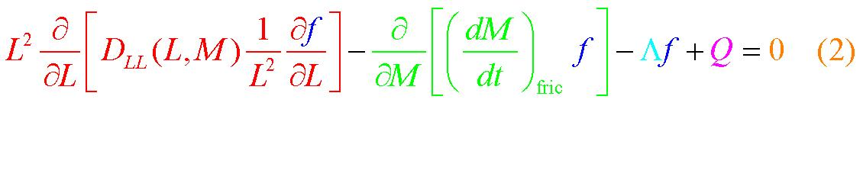

Here ƒ= ƒ(L,M) is a phase space distribution function for confined antiprotons; the magnetic moment is M=P²/2mB and P is its linear momentum. Q is the antiproton source term computed with the SHIELD code, and Λ is the effective rate of antiproton annihilation losses in collisions with exospheric matter. A general description of this transport equation can be found in the literature (e. g., Spjeldvik, 1979).

The radial diffusion coefficients applied here are:

[a] Magnetic fluctuation radial diffusion:
D^{m}_{LL} = D_{0m} L¹⁰ with D₀ = (1–5)x10⁻¹³ s⁻¹
[b] Electric fluctuation radial diffusion:
De_{LL} = D_{0e} L¹⁰/(L⁴ + [M/M₀]²), here D_{0e} =10⁻⁹ s⁻¹ and M₀=1 MeV

The characteristic diffusion time at L = 1.2 is about τ ~ 10 years. At high energies, in the MeV and GeV range, the diffusion mechanism is dominated by the geomagnetic fluctuations. In our modeling we solved Equation (2) by a second order, locally integrated finite difference procedure (e. g., Spjeldvik, 1979; Spjeldvik et al., 1998).

Boundary condition at the outer edge of the magnetosphere was defined as the empirical CR antiproton flux in interplanetary space (i. e., Gusev at al., 2003). We applied the consideration that interstellar CR antiprotons penetrate freely into the magnetosphere until they reach the appropriate cut-off rigidity corresponding to each antiproton's kinetic energy.

Since antiprotons will populate the Earth's magnetosphere both from within (the nuclear collision albedo antiproton source) and from galactic antiprotons in interplanetary space (having traversed much of the heliosphere before reaching Earth), it is of interest to compare the effect of the internal source only. That result is shown in Figure 5.

Figure 5: Magnetospheric Antiprotons stemming from
the "inner" (albedo) source process only.

It can be seen that the "internal" source serves to populate mainly the inner radiation zone, peaking at L~1.2, and that the outer radiation belt has a greatly reduced antiproton population from this mechanism.

The galactic antiprotons arriving at Earth from interplanetary and interstellar space will penetrate into the Earth's magnetosphere according to the geomagnetic rigidity, so that the lower energy antiprotons, below hundreds of MeV kinetic energies penetrate to a shallower depth in the magnetosphere. For a particular energy, this stand-off distance forms an injection boundary. Fluctuations in the geomagnetic field then act to permit diffusion into the magnetosphere confinement region. This is the same mechanism that permits the (much lower energy) solar electrons, protons and various ion species to populate the principal radiation belt region.

When this "external" diffusive source of magnetospheric antiprotons is included, it is clear that the Earth's magnetosphere is populated with antiprotons both from the inside and from the outside, and the latter mechanism is particularly important for L-shells beyond L=2 to 4, depending on antiproton energy.

Figure 6: Magnetospheric Antiprotons stemming from both
the "inner" (albedo) and the "outer" source processes.

The results of the numerical simulations of the antiproton radiation belt structure, based of the combined "inner" and "outer" source mechanism, are shown in Figure 6, where the radial profiles of the antiprotons is depicted for selected kinetic energies. As one can see from this figure, the spread in the L-shell range due to the radial diffusion process over time indeed is a significant process in the magnetospheric charged particle distribution -- even in the deep inner magnetosphere region. This is due to the fact that both source and sink processes for energetic antiprotons are slow enough to allow the radial redistribution process to be an effective diffusive mechanism.

CONCLUSIONS

The modeling carried out herein shows that the Earth's antiproton radiation belt can be created due to the cosmic ray nuclear interactions with the atmospheric constituents H, He and O, reactions that are most effective at altitudes of L=1.2 ± 0.05 (height ~ 1275 km; albedo source) and partially due to diffusive penetration of the CR antiprotons from the interstellar medium into the Earth's magnetosphere.

Radial diffusion of both antiproton source components was simulated with a transport equation for the geomagnetic equatorial region. The Earth's antiproton belt possesses about 6-60 times larger antiproton fluxes compared to the galactic fluxes observable in interplanetary space during minimum/maximum solar activity at essentially all energies within the confinement zone.

In populating the Earth's antiproton radiation belt, the nuclear collision albedo antiproton source is more powerful than the interstellar antiproton penetration mechanism. In the natural state, the radiation belt antiproton fluxes are spread over a wide L-shell range due to diffusion. This shows that natural radial diffusion is a significant process even in the inner magnetosphere. This situation may become considerable different if magnetospheric antiprotons should become harvested by mankind's future space activity.

Acknowledgements:

One of us (WNS) was the beneficiary of a summer visitorship to INPE in Sao Jose Dos Campos, Brazil. Drs. A. Gusev, K.Choque, and G.Pugacheva wish to thank the Brazilian agencies CNPq and CAPES for the research fellowships that enabled this work.

References:

Dementyev, A. V., N. M. Sobolevsky, SHIELD - Universal Monte Carlo Hadron Transport Code.., Radiation Measurements, 30, 553, 1999.

Gusev, A. A., I. M. Martin, G. I. Pugacheva, and A. Turtelli, Jr., Energetic positron population in the inner zone, Il Nuovo Cimento, C, 19, n4, 461-468, 1996.

Gusev, A. A., U. B. Jayanthi, G. I. Pugacheva and W. N. Spjeldvik, Journal of Geophysical research, 106 (A11), 26111, 2001.

Gusev, A.A., U. B. Jayanthi, G. Pugacheva, et al., Antiproton radiation belt produced by cosmic rays in the Earth’s radiation belt region , Geophysical Research Letters, 30, 1161, 2003.

Gusev, A. A., K. T. Choque, U. B. Jayanthi, G. I. Pugacheva, and N. J. Schuch, Interstellar antiproton flux in the leaky-box model, Contribution at the 7th Scientific Colage, Brazil 2004.

Jones, F. C, A. Lukasiak and V. S. Ptuskin, Leaky box cosmic ray model, Applied Physics Journal, 547, 264, 2001.

Letaw, J. R., R. Silberberg and C. H. Tsao, Proton nucleus total inelastic cross sections, Astrophys. J. Suppl., Ser., 51, 271-275, 1983.

Selesnick, R. S. and R. A. Mewaldt, Atmospheric production of radiation belt light isotopes, Journal of Geophysical Research, 101, .A9, 19745-19759, 1996.

Spjeldvik, W. N.: "Expected Charge States of Energetic Ions in the
Magnetosphere", Space Science Reviews, 23, 449, 1979.

Spjeldvik, W.N., G.I. Pugacheva, A.A. Gusev, et al., Hydrogen and helium isotope radiation belts, Annales Geophysicae, 16, 931-939, 1998.

Tan, L. C. and L. K. Ng, Parametrization of pbar invariant cross-section in p-p., Phys. Rev., D26, 1179, 1983.

